CALS Charter Middle School
3838 Eagle rock Blvd.
Los Angeles, CA 90065
Mr. Garza and Mr. Rosas
2014-2015
“The charm of history and its enigmatic lesson consist in the fact that, from age to age, nothing changes and yet everything is completely different.” Aldous Huxley

Course Outline
This course is designed to focus on the human condition through the matrix of ancient civilizations. Humanities is defined in this course as the following: The study of what it means to be human is a global interdisciplinary course of history, art, architecture, technology, logic, and environment that seeks to identify and analyze the constructs, achievements, culture, and driving forces that makes humans distinct from other animals in nature. The study of Humanities does not seek final answers but serves as a cultivation and exercise of ways of thinking unique to understanding the evolving human condition and developing high culture and democratic leadership through critical thinking, critical questioning, problem solving, evaluation of evidence, the analysis of human achievement both physical and ideological, the development of empathy, and designing constructs that reflect an understanding, appreciation, or growing empathy of the human experience through diverse modes of communication relative to the 21st century. These ways of thinking are not to be done in isolation but done through deliberative dialogue within a community of scholars.
This course is designed to focus on key themes or ideas of Ancient Civilizations. Students will be exposed to the intellectual achievements of the ancient world. It is my hope that the students through careful study are rewarded with insight on how the past affects the present. Moreover through the study of history, students will gain problem-solving skills by understanding how people of the past dealt with problems through conflict, collaboration, compromise, ingenuity, strategy, intellect, and other traits that define the human condition. It is the realization of the large realm of human culture and its variances, or differences that help students become the leaders of tomorrow.
Students, or our young humanists, will first learn about early man and witness the rise of humans from a fearful creature to a sophisticated being able to pass on a culture of problem solving and adaptation through tool-making and migration to contend with the perils of the natural world. Then these humanists will learn about the Near Eastern civilizations of Mesopotamia and Egypt. Next these young humanists will examine the artistic sensibilities of the Greeks, and Greco-Roman conceptions of knowledge, law, and political policy. The Final portion of this survey will focus on Jewish, Christian, and Asian contribution to morality and law, a unique characteristic of the human experience.
This course follows the California State Standards for the 6th grade Social Studies and 6th grade Common Core Standards. We will use a variety of learning tools throughout the year. In this humanities class every unit will incorporate group work, presentations, and hands on learning experiences.
In our literature rich school we will be connecting primary source documents, myths, articles , and other informational text to major concepts of the study of humanities. We will be reading essential portions of informational text and literature essential to understanding the Ancient World. Quite often, a lot of the reading may be preselected online resources and readings. The Students will want to have access to the internet. Our website is:
http://wanderingsintheancientworld.weebly.com/
“Education is the kindling of a flame, not the filling of a vessel” Socrates
Dispositions of a Humanist
In this course students will be taught to think in multiple perspectives in the study of early civilizations. The main three are the following:
Disciplinary Lens | Description
Anthropologist | I study human life through the behavior, culture, and physical remains of people today and those who lived a long time ago. I focus on how a people’s culture is similar or different to my own.
Archeologist | I study human life and culture by looking at remaining physical evidence that people have created a long time ago. For example, I study graves, pottery, tools, and anything that people have created that describes their culture, or the way they lived.
Historian | I study human life through the study, collection, and organization of different written sources. I analyze and compare different written sources to present my learning and research to others.

Grading Policy
All work will be assessed on a points based system. Students will be assessed using quizzes, tests, individual/group projects, notebooks, homework, class work, oral presentations, and participation. Below is the break down of how the grades will be assessed.
Performance Assessments and Essays – 20%
Exams/ Tests-20%
Classwork/Homework-10%
Quick Checks (quizzes, exit tickets, etc)-50%
We will be using the CALS Charter Middle School grading scale found below.
997% - 100% | A+
993% - 96% | A
990% - 92% | A-
887% - 89% | B+
883% - 86% | B
880% - 82% | B-
777% - 79% | C+
773% - 76% | C
770% - 72% | C-
00% - 69% | F

School Supplies
All 6th grade students will be receiving a supply list. They will be required to bring all their materials to class everyday. They will be checked in all classes. All supplies should be in within the first week of school. To access the supply list or another syllabus via the Internet, please go to http://wanderingsintheancientworld.weebly.com/. Find on the navigation panel the tab called Resources. Click on it and you will see a pull down menu. Select Humanities Class Resources.

Absent Policy
We will be utilizing a system called “Sorry You Were Absent” (SYWA). The student will also collect any handouts and list any activities, quizzes, and tests that will need to be made up when he/she was absent. When the absent student returns he/she must pick up the SYWA sheet from the mailbox. If there are any questions, the student, who missed class can talk to the SYWA monitor. However, the best thing to do is simply e-mail me at J.Garza@pucschools.org,
“The expectations of life depend upon diligence; the mechanic that would perfect his work must first sharpen his tools.”
Confucius

Expectations
I have very high expectations in our class. The students will be expected to follow CALS Charter Middle School Habits of A Scholar at all times. Following these Habits of A Scholar will ensure that every student in our class receives the highest learning experiences that can be achieved.
Below you will find the Habits of A Scholar that we hold so high in regard.
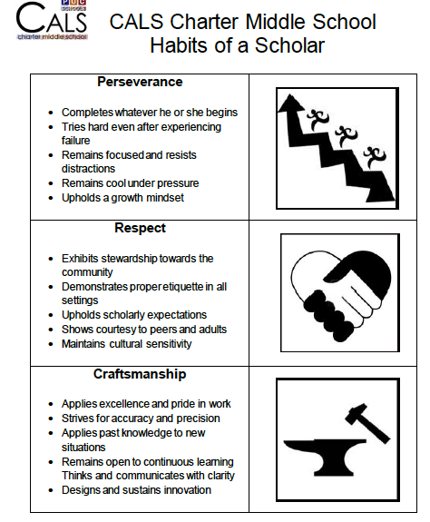
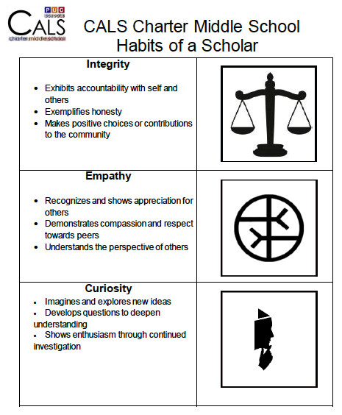
Consequences
- 1st Verbal Warning (Color Card Change From Green to Yellow)
- 2nd Verbal Warning (Color Card Change From Yellow to Red)
- Possible Reflection Letter, Small Behavior Form or Phone Call Home
(Larger Behavior Reflection Form for serious offenses)
- Parent Conference

Rewards
Humanities Student of the Month
Good Slips
Pizza Parties
Good Grades
Notes to Parents
Great Feedback
New Knowledge
Calls Home
Great Feeling of SUCCESS!

Homework Policy
- Homework must be written in their logs at the end of class.
- All work must be done neatly, be properly labeled, and turned in on time.
- Blue or Black Ink Only (unless specified).
- Every assignment should be YOUR BEST WORK.
- Homework must be checked and log signed off by a parent/guardian every day after he/she has reviewed the homework to ensure student success.
- Late work will only be accepted with a late work pass. Each student is given two per trimester. In order to be valid they must be signed by parent(s) (No Exceptions).

Communities of Practice Guidelines: This will come into play when students will have telecollaborative activities using the power of the Internet.
- Follow the guidelines of each learning experience
- Hold each other accountable
- Support each other
- Remember you are all called to be leaders

Group Work Guidelines
- Follow the guidelines given with each learning experience.
- Use low voices as not to disturb our neighboring class.
- Follow directions carefully.
- Every member must work and do their assigned job (participation points will be given).
- Use time effectively.

Test Taking
- No talking during or after quizzes or tests.
- Keep all eyes on your own paper at all times.
- Have a book to read if you finish early.

Entering Class
- Line up in an orderly fashion outside of class.
- Enter the class professionally. This means that shirts are tucked in neatly, and pants are at waist level with a belt. Hoods are NEVER to be worn over the head in class and absolutely NO hats in class!
- Backpacks are to be put neatly on chairs.
- Always be Respectful.
- Students will take out the homework folder and homework log and place it on the right corner of his/her desk showing the assignment and the correct calendar page.
- Be ready to start the Warm Up assignment immediately.

Leaving Class
- Complete the Exit Ticket before you leave.
- At the end of class write homework in log.
- Pack up material quietly when asked to do so.
- Clean up your area.
- Show the Homework Log as you exit.
- Wait for dismissal by Mr. Garza.

Food/Drink & Restroom Policy
Food, mints, gum, or candy are not allowed in class.
Bottled Water is ok (No other drinks).
Restroom breaks should be only in case of emergency since there are enough breaks for the students to use the restrooms.
Students will have only two bathroom passes for each trimester. Please use them wisely. If student has a medical condition in which he or she needs to use the restroom often, please notify me as soon as possible.
Note to Parents/Guardians
Please read the syllabus and class expectations. It is essential that you are aware of our classroom policy. All students will be expected to honor our policy. If you have any questions please drop in any time. I have an open door policy. Your child can also schedule conferencing Monday - Thursday. These conferences are a good way to go over class material and any questions they may have. Please encourage your child to see me. You may also call the school at 323-254-4427 or email me at j.garza@pucschools.org or Skype me at Joecadre14 from 4:00 p.m to 8:00 p.m. I look forward to a wonderful year with everyone.
-----------------------------------------------------------------------------------------------------------------------------
I ensure that I have read the syllabus and have navigated to the website to confirm that there are no problems connecting to the website. If there are any problems reaching the website I will notify Mr. Garza by the end of the first week of school.

Student Signature (please print) :_______________________________
Date:__________
Student Cohort:______________________________________
(please print)

Parent Signature (please print) :__________________________________________ Date:__________
Parent email_____________________________________

